Digital Image Processing Quiz 02

|  |  |
| --- | --- |
| Id No | Name |
| 27 | Mohanto Tushar chandra |

**Image denoising** is highly demanded in the field of image processing, since noise is usually inevitable during the process of image acquisition and transmission, which significantly degrades the image visual quality and increases the difficulty in the high-level image analysis . There exist two different types of noise that are commonly encountered in real world: additive Gaussian noise and impulse noise. In literatures, there are numerous denoising methods that have been proposed separately for restoring images corrupted by either impulse noise or Gaussian noise. Here gives a brief review on the two types of noise, respectively. Additive Gaussian noise is usually generated during image acquisition and characterized by adding each image pixel a value from a zero-mean Gaussian distribution. It is utilized to model thermal noise, and under certain conditions it is also the limit of other noises, such as photon counting noise and film grain noise. For Gaussian noise removal, we refer readers to [4] for a comprehensive review on the developments of additive Gaussian noise removal methods. It is important to stress that sparsity-based and non-local schemes have emerged as promising approaches with very impressive denoising results for Gaussian noise.

PSNR of Various Methods for Gaussian plus Salt-and-Pepper Noise Removal (dB)

|  |  |  |  |  |  |  |  |  |  |  |  |  |  |
| --- | --- | --- | --- | --- | --- | --- | --- | --- | --- | --- | --- | --- | --- |
| **Image** | ***Lena*** | | | ***Boat*** | | | ***House*** | | | ***Barbara*** | | | **Avg.** |
| **r** (%) | 30 | 40 | 50 | 30 | 40 | 50 | 30 | 40 | 50 | 30 | 40 | 50 |
| **Noisy** | 10.63 | 9.40 | 8.44 | 10.66 | 9.42 | 8.46 | 10.69 | 9.46 | 8.50 | 10.58 | 9.36 | 8.39 | 9.50 |
| **TV** | 31.33 | 30.85 | 30.20 | 29.20 | 28.53 | 27.66 | 31.63 | 31.10 | 30.36 | 26.86 | 26.18 | 25.40 | 29.11 |
| **IFASDA** | 32.69 | 32.27 | 31.70 | 30.82 | 30.28 | 29.50 | 32.68 | 32.26 | 31.69 | 29.47 | 28.59 | 27.45 | 30.78 |
| **Proposed** | **34.02** | **33.59** | **33.00** | **31.54** | **30.95** | **30.17** | **34.86** | **34.43** | **33.82** | **32.33** | **31.95** | **31.12** | **32.65** |

PSNR of Various Methods for Gaussian plus Random-Valued Impulse Noise Removal (dB)

|  |  |  |  |  |  |  |  |  |  |  |  |  |  |
| --- | --- | --- | --- | --- | --- | --- | --- | --- | --- | --- | --- | --- | --- |
| **Image** | ***Lena*** | | | ***Boat*** | | | ***House*** | | | ***Barbara*** | | | **Avg.** |
| **r** (%) | 10 | 20 | 30 | 10 | 20 | 30 | 10 | 20 | 30 | 10 | 20 | 30 |
| **Noisy** | 18.78 | 16.05 | 14.36 | 18.88 | 16.13 | 14.42 | 18.87 | 16.08 | 14.42 | 18.65 | 15.93 | 14.24 | 16.40 |
| **TV** | 31.52 | 30.94 | 30.16 | 28.83 | 28.10 | 27.39 | 31.54 | 30.89 | 29.84 | 25.47 | 24.88 | 24.18 | 28.65 |
| **IFASDA** | 32.17 | 31.47 | 30.43 | 29.29 | 28.46 | 27.64 | 31.88 | 31.13 | 29.87 | 25.69 | 25.06 | 24.30 | 28.95 |
| **Proposed** | **33.63** | **32.72** | **31.76** | **31.04** | **29.64** | **28.80** | **34.14** | **33.30** | **32.20** | **30.80** | **29.20** | **27.62** | **31.24** |

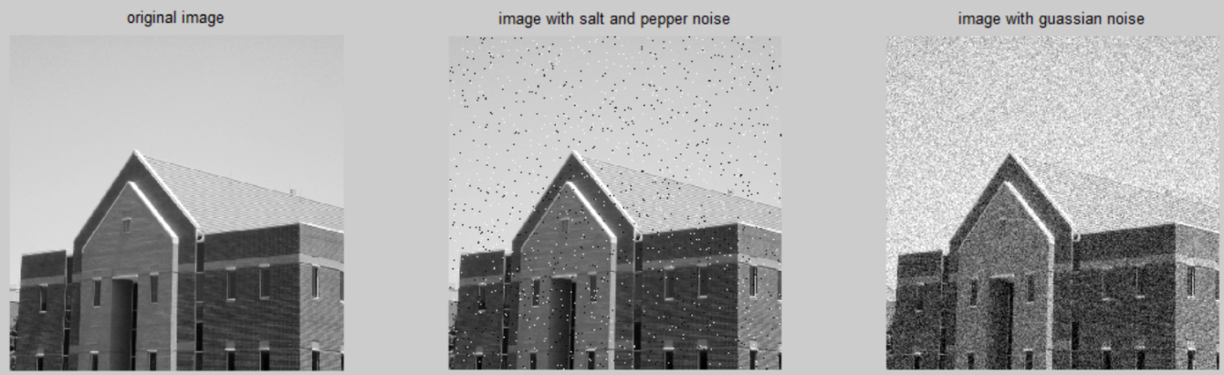

(a)proposed 32.20 db (b)Tv 29.84 db (c)Noisy 14.42 db

he PSNR block computes the peak signal-to-noise ratio, in decibels, between two images. This ratio is used as a quality measurement between the original and a compressed image. The higher the PSNR, the better the quality of the compressed, or reconstructed image.

The mean-square error (MSE) and the peak signal-to-noise ratio (PSNR) are used to compare image compression quality. The MSE represents the cumulative squared error between the compressed and the original image, whereas PSNR represents a measure of the peak error. The lower the value of MSE, the lower the error.

To compute the PSNR, the block first calculates the mean-squared error using the following equation:

*MSE*=∑*M*,*N*[*I*1(*m*,*n*)−*I*2(*m*,*n*)]2*M*∗*N*

In the previous equation, M and N are the number of rows and columns in the input images. Then the block computes the PSNR using the following equation:

*PSNR*=10log10(*R*2*MSE*)

In the previous equation, R is the maximum fluctuation in the input image data type. For example, if the input image has a double-precision floating-point data type, then R is 1. If it has an 8-bit unsigned integer data type, R is 255, etc.

Mean Filtering and Median Filtering implement Method

I = imread('peppers.png');

H = fspecial('average', [5 5]);

I = imfilter(I, H);

imshow(I)

medfilt method implement formula

I = imread('eight.tif');

J = imnoise(I,'salt & pepper',0.02);

K = medfilt2(J);

imshow(J) figure,

imshow(K)

In this section, extensive experimental results are provided to evaluate the performance of the proposed algorithm. In the simulations, images will be corrupted by Gaussian noise with standard deviation σ and impulse noise density level r. Note that the density level can be detected automatically by the median filters [8, 9], thus the only parameter required known is standard deviation σ of Gaussian noise. Two stateof-the-art algorithms compared with our proposed method are: TV [10], IFASDA [11]. Extensive experiments are carried out on four benchmark images, where the standard variance σ of Gaussian noise equals 10 and the impulse noise level r varies from 30% to 50% for salt-and-pepper noise and from 10% to 30% for random-valued noise. Table 2 and Table 3 present the PSNR results of the three comparative denoising algorithms on all test images for Gaussian plus salt-and-pepper impulse noise and Gaussian plus random-valued impulse noise, respectively. Obviously, the proposed method considerably outperforms the other methods in all the cases, with a PSNR improvement of about 2 dB on average over the second best algorithm (i.e. IFASDA [11]). In particular, for Image Barbara, which is rich in textures, in the case of Gaussian plus salt-and-pepper impulse noise with σ = 10 and r = 50%, the PSNR gain achieved by the proposed method over IFASDA is as high as 3.6 dB.